

***Faculty of Science and Technology***

**Assignment Coversheet**

|  |  |
| --- | --- |
| **Student ID number &**  **Student Name** | U3248529  Ugyal Wang |
| **Unit name** | Software |
| **Unit number** | 4483 |
| **Unit Tutor** | Gurpreet |
| **Assignment name** | ST1 Capstone Project – COLT 1 2023 |
| **Due date** | 30/04/2023 |
| **Date submitted** | 30/04/2023 |

**You must keep a photocopy or electronic copy of your assignment.**

**Student declaration**

I certify that the attached assignment is my own work. Material drawn from other sources has been appropriately and fully acknowledged as to author/creator, source and other bibliographic details.

**Signature of student: ugyal wang Date: 30/04/2023**

Table of Contents

Introduction 1

Methodology 2

Stage 1: Algorithm Design Stage 2

Dataset Description 3

Exploratory Data Analysis 3

Predictive Data Analytics Stage 11

Model Preparation and Development 14

Stage 2: Algorithm Implementation Stage 22

Stage 3: Software Deployment Stage 22

Conclusions 23

References 23

# Introduction

# Air travel is a crucial mode of transportation for millions of people worldwide, and passenger satisfaction is a key factor in determining the success of airlines. Understanding the factors that influence passenger satisfaction is essential for airlines to tailor their services and enhance customer experiences. This comprehensive data set, "Airline Passenger Satisfaction," provides an extensive collection of data points related to passenger satisfaction, offering valuable insights into various aspects of the airline industry.

For many people throughout the world, flying has been a necessary form of transportation, and airline’s business depends heavily on how well their passengers are treated. In order to customise their services and improve client experiences, airlines must have a thorough understanding of the aspects that affect passenger happiness. "Airline Passenger Satisfaction," a comprehensive data set, offers a large collection of data points linked to customer happiness and offers insightful information on numerous facets of the airline sector.

# The data set consists of a wide range of information, including passenger demographics, flight attributes, and passenger satisfaction ratings. It multiple international airlines, covering diverse regions, routes, and flight classes. The data set is sourced from a reputable online survey conducted among airline passengers, ensuring reliability and accuracy.

# This data collection has a great deal of promise for in-depth investigation and analysis of elements influencing passenger happiness. Researchers, analysts, and industry stakeholders may learn a lot about passenger preferences, views, and behaviours by analysing the data. In order to enhance their services, boost customer happiness, and gain a competitive edge in the fiercely competitive airline sector, airlines may be able to use this information to make educated decisions and put into practise focused initiatives.

# A useful understanding of passenger behaviour, preferences, and satisfaction within the context of the aviation sector may be gained from the examination of this data collection, which can also contribute to the larger area of aviation research. It may also be used as a benchmark for assessing airlines' performance and spotting patterns and trends in the market.

In conclusion, this extensive data collection on airline passenger happiness provides a wealth of data for in-depth study, analysis, and insights into the variables that affect customer satisfaction in the airline. The data collection is a useful resource for aviation academics, analysts, and stakeholders since it has the potential to improve airline services, customer experiences, and industry knowledge.

# Methodology

The methodology used for developing the software platform involves 3 stages as outlined below:

1. Design and development of decision support algorithms based on exploratory data analysis and predictive analytics, for identifying the best performing algorithm for solving a real world problem.
2. Implementation of best performing algorithm as a desktop Tkinter software tool.
3. Deployment of the tool as a web or cloud enabled platform tool.

## Stage 1: Algorithm Design Stage

Stage 1 is most important preliminary stage and depending on the complexity of the problem and dataset used, the design of algorithms for exploratory data analysis and predictive analytics algorithms will vary. However, the workflow for algorithm development will be as outlined in the Figure 1 schematic shown below:

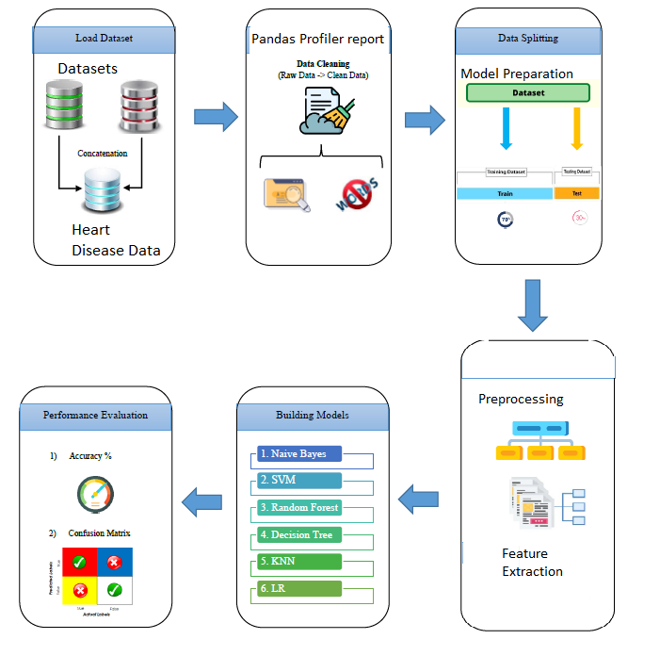

Figure 1: Schematic for Algorithm Design Methodology for Heart Disease Prediction

The details of each building block in Figure 1 schematic for algorithm design is described in the next few sections.

### Dataset Description

The target/class variable includes the result of the customer satisfaction which represents how much the customer is satisfies while traveling in airway . Therefore, the task at hand is to develop a software tool to predict the result of satisfied the customer are using the results of the above mentioned customer information and about their satisfaction. The data was originally collected by Teej Maharjan, who goes by the username Teej on Kaggle. [https://www.kaggle.com/datasets/teejmahal20/airline-passenger-satisfaction].

### Exploratory Data Analysis

The first phase of the software development activity involved understanding the data, basic exploratory data analysis and visualisation. Google Colab was chosen as the experimental environment as it incorporates virtual hardware and resources which does not require additional physical hardware requirement and can be ran directly of a web browser. The python language was used to create the scripts which ran directly on online Jupyter notebook using Google Colab with the help of free google account created, and by saving all the notebook files virtually on google drive without additional configurations. Before the exploratory data analysis can begin, some of the python libraries for EDA need to be imported and dataset acquired, by using the following Python script

from google.colab import drive

drive.mount("/content/drive")

#Import Required Packages for EDA

import os

import pandas as pd

import numpy as np

import matplotlib.pyplot as plt

import seaborn as sns

import missingno as msno

import plotly.graph_objects as go

import plotly.express as px

%matplotlib inline

import warnings

warnings.filterwarnings('ignore')

#Read the dataset/s

df = pd.read_csv('/content/drive/MyDrive/Capstone Project/test.csv')

1. The EDA starts with understanding the basic description of data as described next:

#1. Checking description(first 5 and last 5 rows)

df.head()

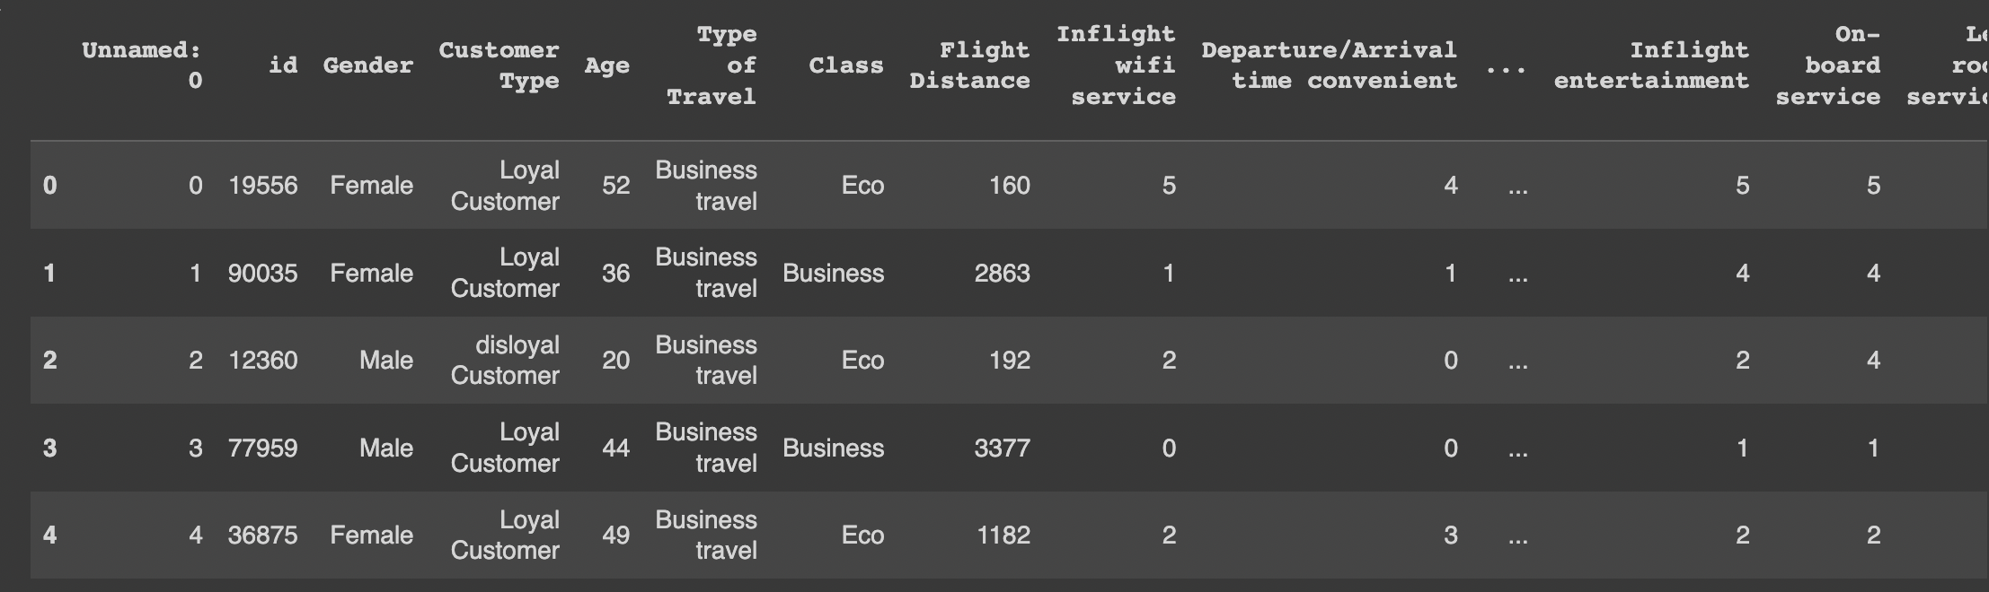

df.tail() #last 5 rows

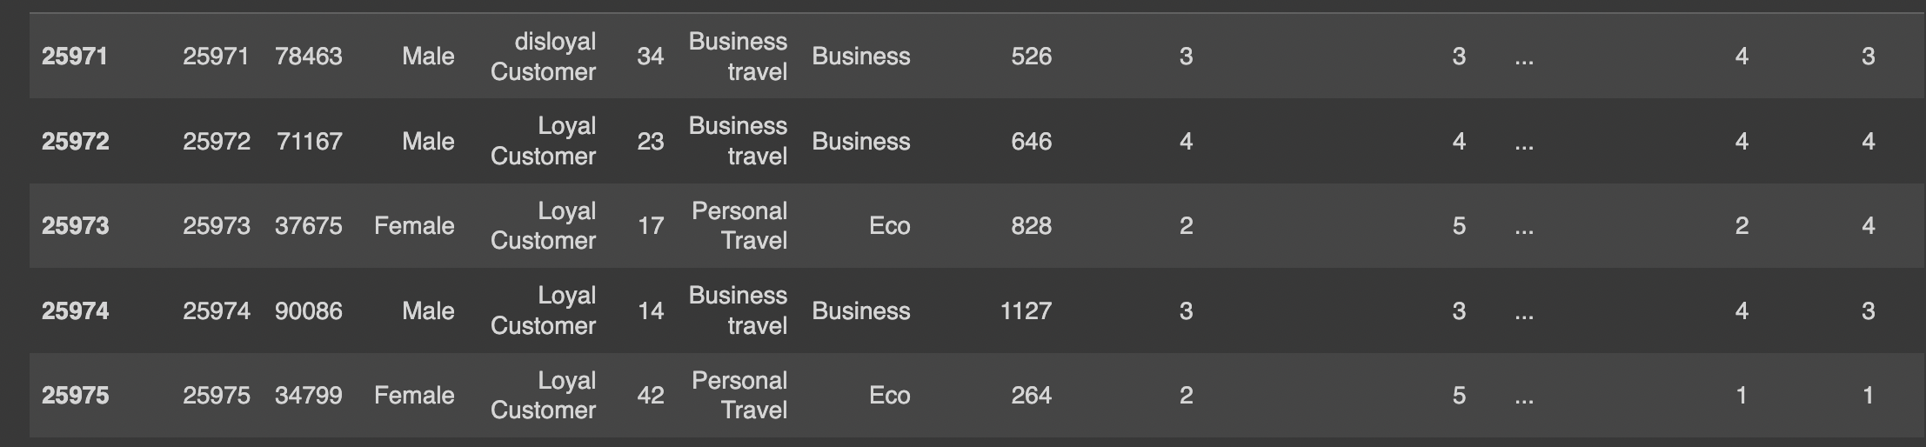

#rows and columns-data shape(attributes & samples)

df.shape

(25976, 25)

# name of the attributes

df.columns

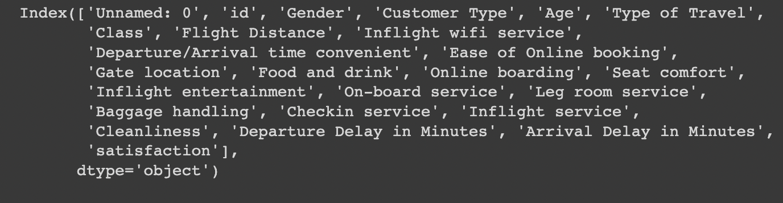

#unique values for each attribute

df.nunique()

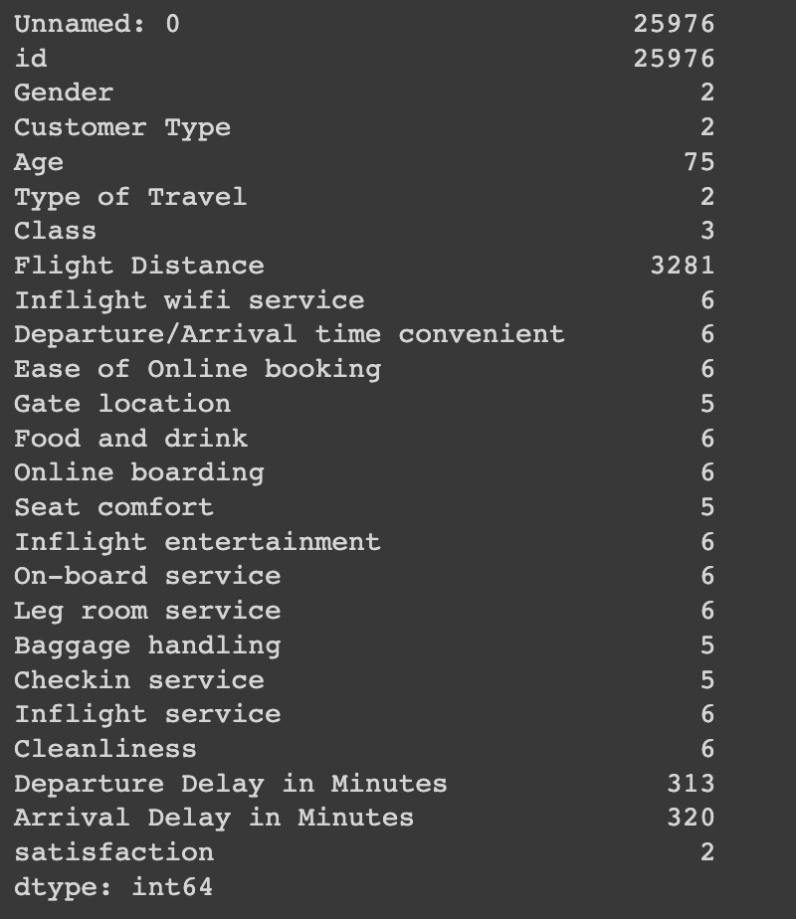

#Complete info about data frame

df.info()

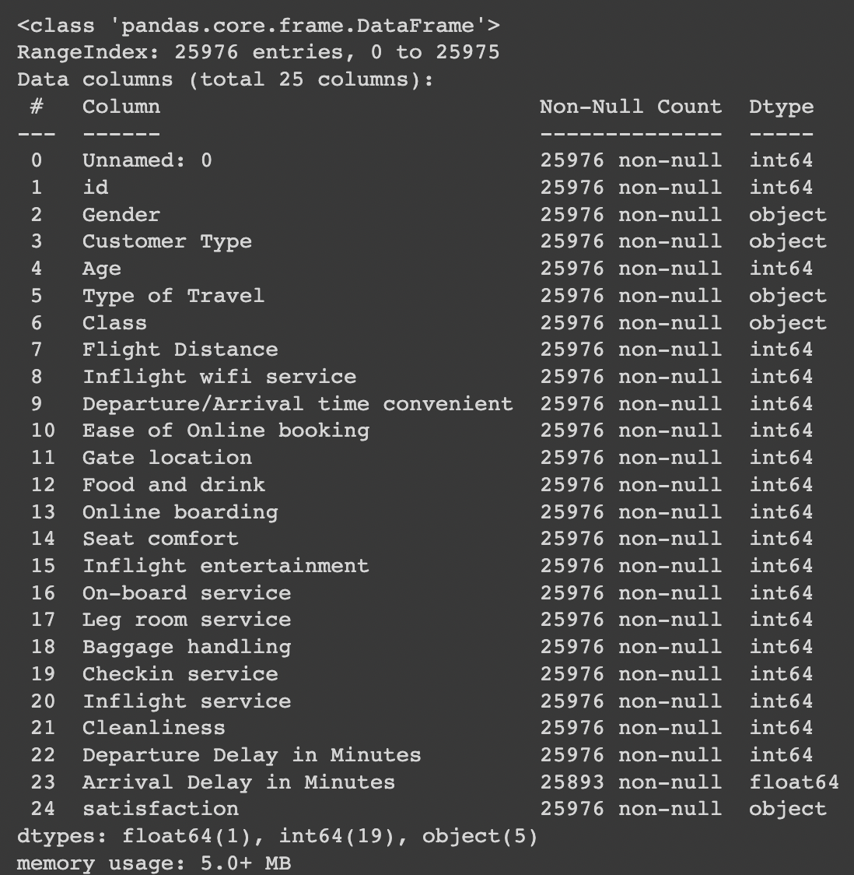

#3. Visualising data  distribution in detail

fig = plt.figure(figsize=(18,18))

ax=fig.gca()

df.hist(ax=ax,bins=30)

plt.show()

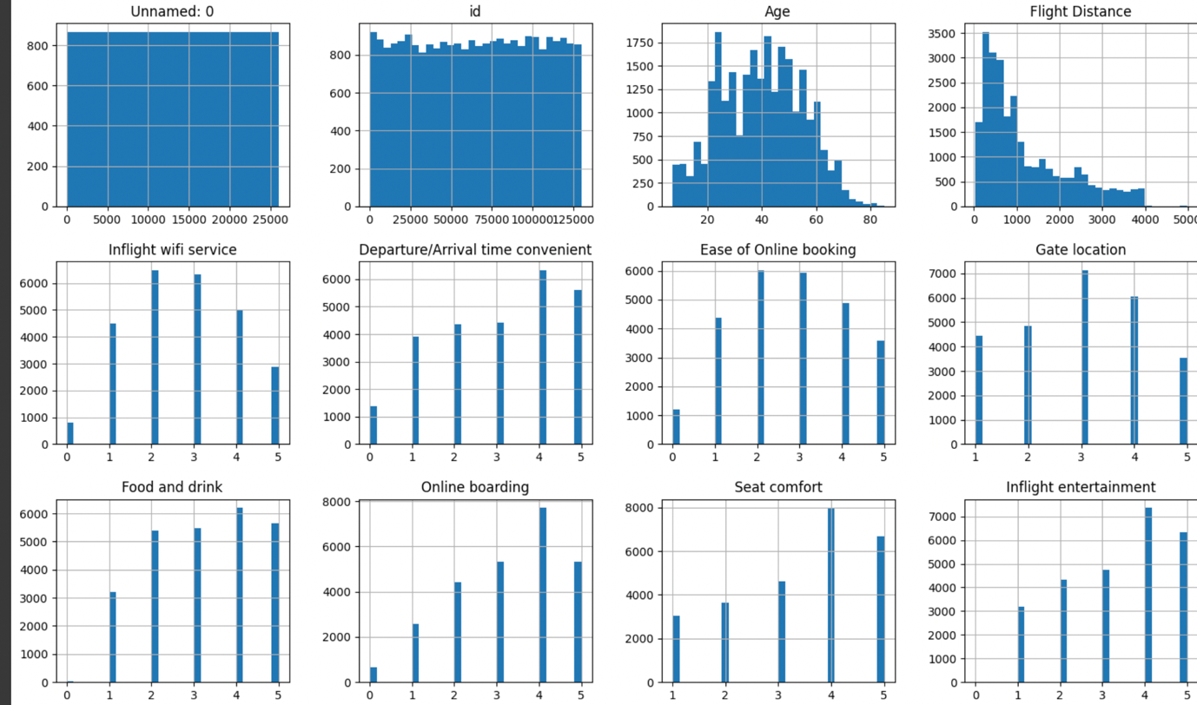

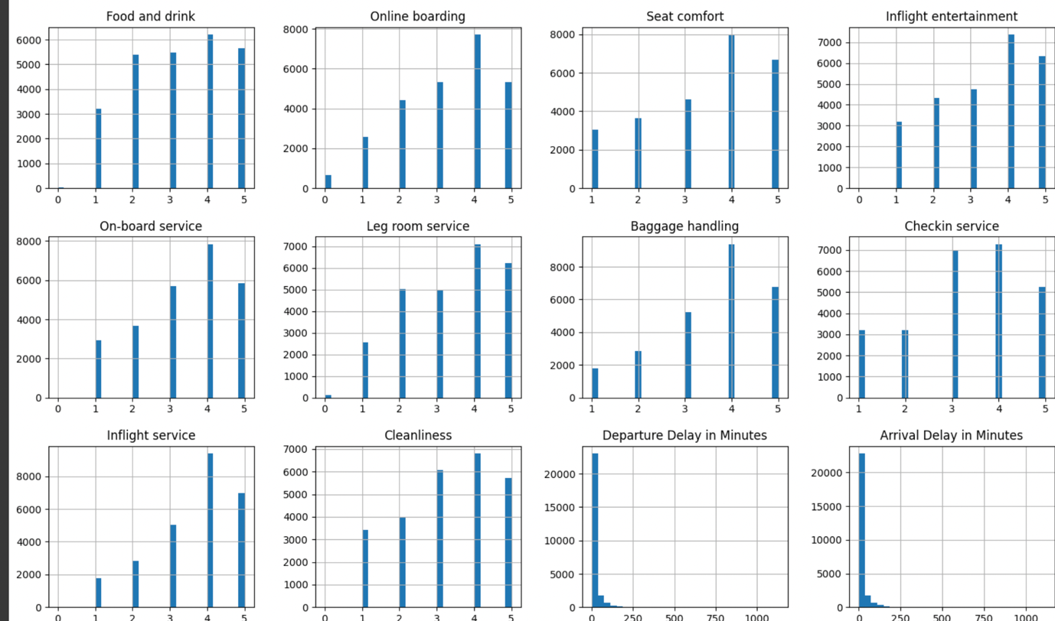

#detecting outliers

df.plot(kind='box', subplots=True,

        layout=(5,5),sharex=False,sharey=False, figsize=(20, 10), color='deeppink');

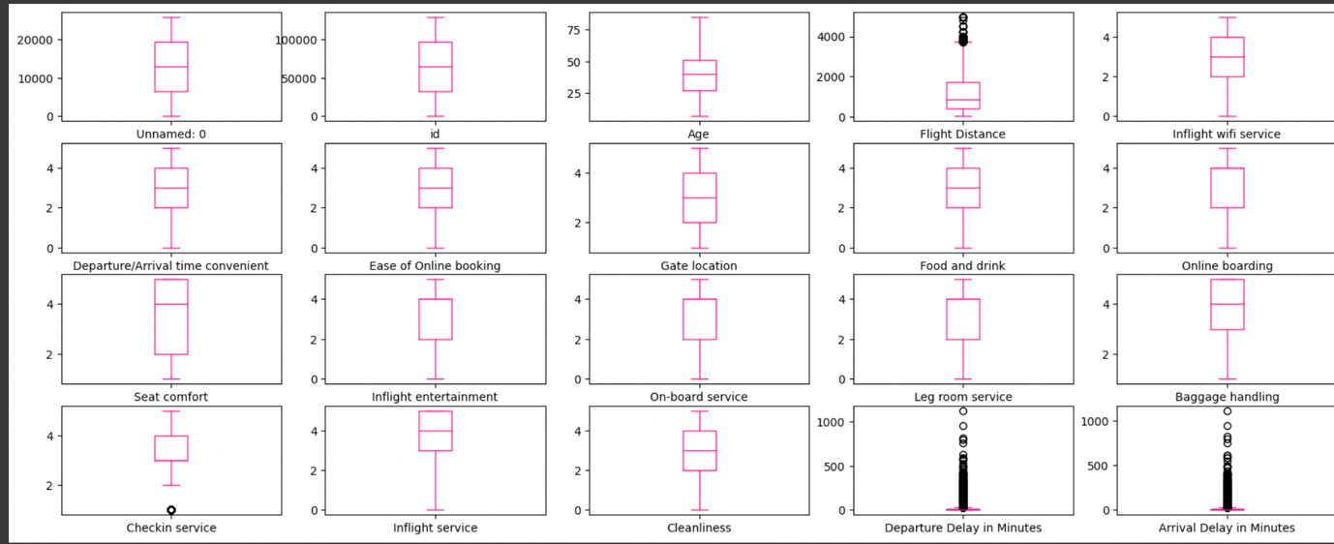

#identify the outliers

# define continuous variable & plot

continous_features = ['Age','Flight Distance','Departure Delay in Minutes','Arrival Delay in Minutes']

def outliers(df_out, drop = False):

for each_feature in df_out.columns:

feature_data = df_out[each_feature]

Q1 = np.percentile(feature_data, 25.) # 25th percentile of the data of the given feature

Q3 = np.percentile(feature_data, 75.) # 75th percentile of the data of the given feature

IQR = Q3-Q1 #Interquartile Range

outlier_step = IQR * 1.5 #That's we were talking about above

outliers = feature_data[~((feature_data >= Q1 - outlier_step) & (feature_data <= Q3 + outlier_step))].index.tolist()

if not drop:

print('For the feature {}, No of Outliers is {}'.format(each_feature, len(outliers)))

if drop:

df.drop(outliers, inplace = True, errors = 'ignore')

print('Outliers from {} feature removed'.format(each_feature))

outliers(df[continous_features])

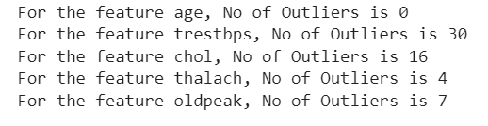

#drop the outliers

outliers(df[continous_features], drop = True)

For the feature Age, No of Outliers is 0

For the feature Flight Distance, No of Outliers is 584

For the feature Departure Delay in Minutes, No of Outliers is 3569

For the feature Arrival Delay in Minutes, No of Outliers is 25976

#checking target value distribution

print(df.satisfaction.value_counts())

fig, ax = plt.subplots(figsize=(5,4))

name = ["satisfied", "neutral or dissatisfied"]

ax = df.satisfaction.value_counts().plot(kind='bar')

ax.set_title("Airline Satisfaction", fontsize = 13, weight = 'bold')

ax.set_xticklabels (name, rotation = 0)

# To calculate the percentage

totals = []

for i in ax.patches:

totals.append(i.get_height())

total = sum(totals)

for i in ax.patches:

ax.text(i.get_x()+.09, i.get_height()-50, \

str(round((i.get_height()/total)*100, 2))+'%', fontsize=14,

color='white', weight = 'bold')

plt.tight_layout()

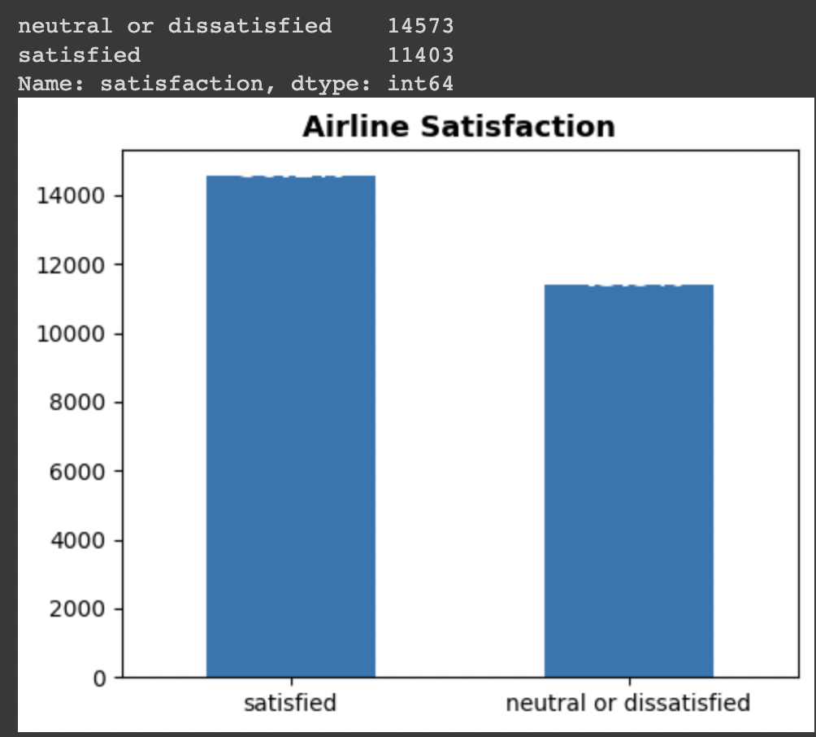

#check correlation between variables

sns.set(style="white")

plt.rcParams['figure.figsize'] = (25, 10)

sns.heatmap(df.corr(), annot = True, linewidths=.5, cmap="Blues")

plt.title('Corelation Between Variables', fontsize = 30)

plt.show()

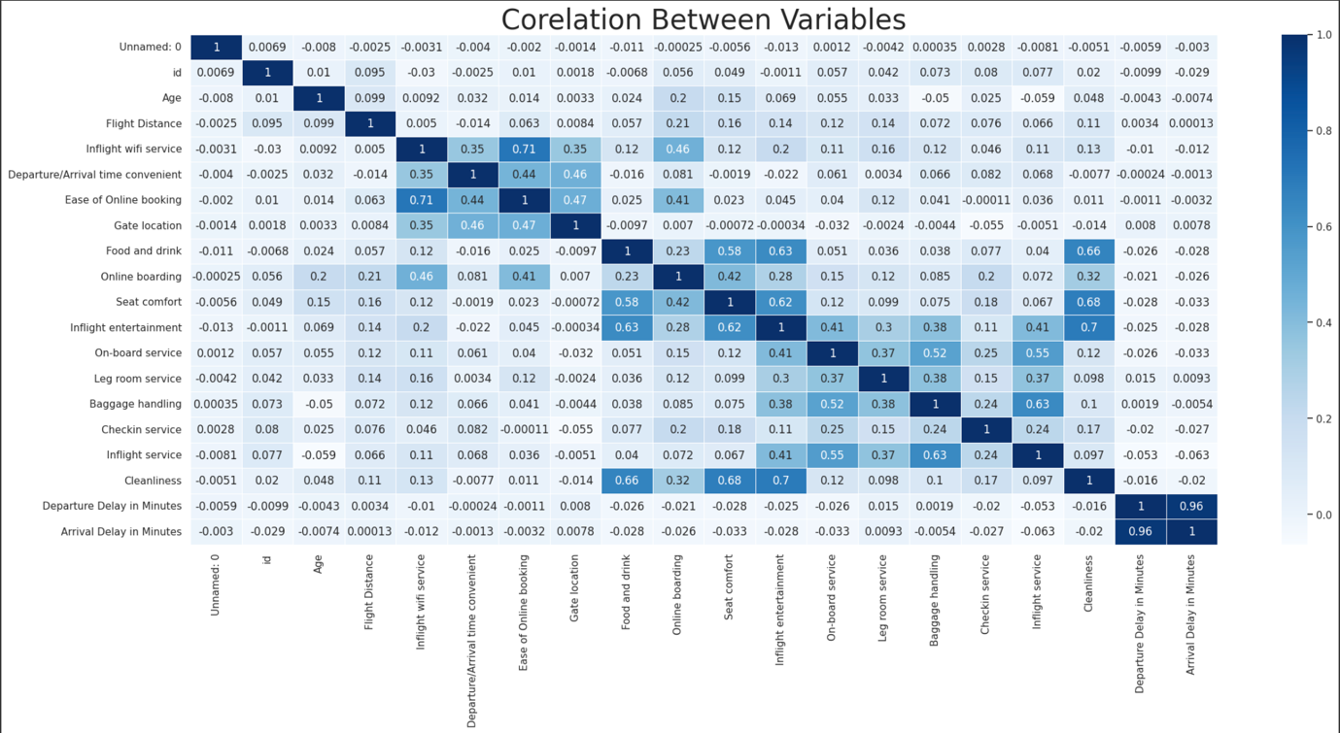

!pip install <https://github.com/pandas-profiling/pandas-profiling/archive/master.zip>

#obtain full profiler report

#restart kernel

#re-run import libraries and data

import pandas as pd

import numpy as np

from pandas_profiling import ProfileReport

profile = ProfileReport(df,title=" Airline Satisfaction EDA",

                        html={'style':{'full_width':True}})

profile.to_notebook_iframe()

profile.to_notebook_iframe()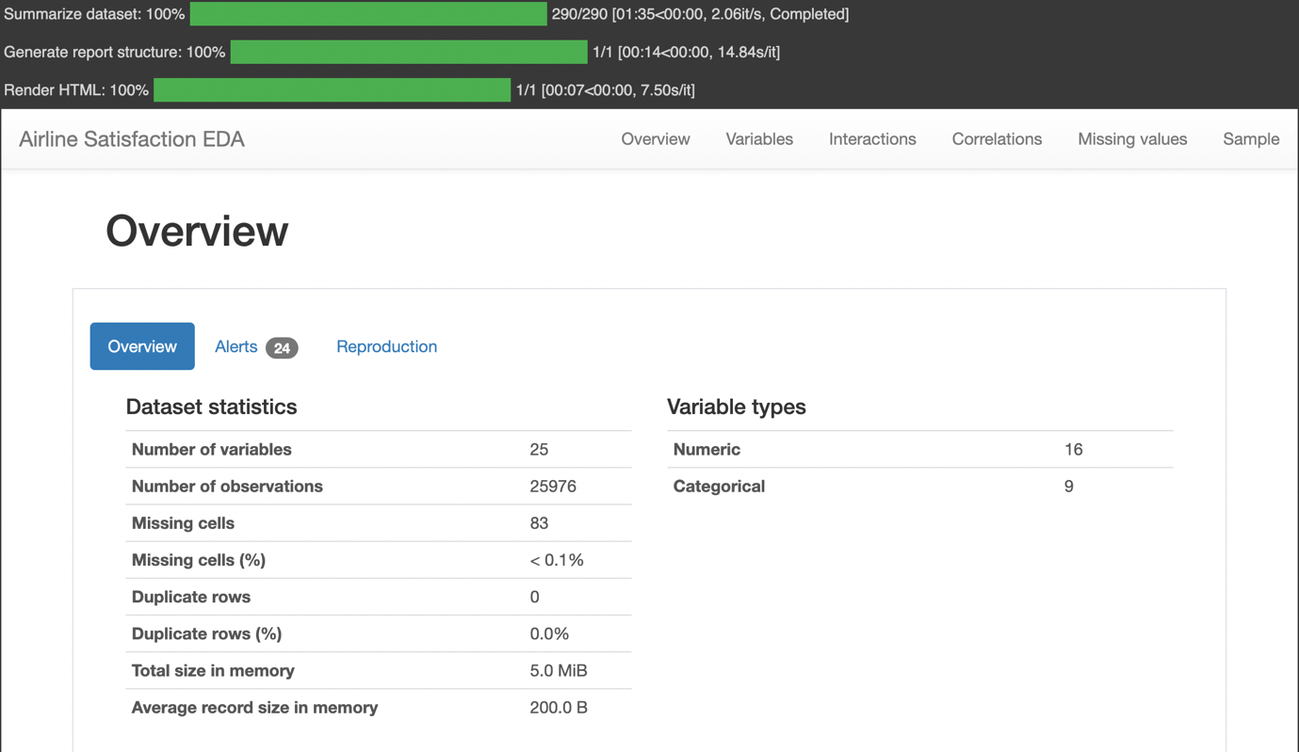

### Predictive Data Analytics Stage

For predictive analytics, several processing steps are required. These include pre-processing, classifier comparison to identify the best machine learning classifier and performance evaluation with different objective metrics, such as accuracy, classification report, confusion matrix, ROC-AUC curve and prediction report was obtained using the Python scikit-learn package. Each of these steps are described next.

* Pre-processing: Since the dataset consists of a combination of continuous and categorical attributes/variables, there is a need to pre-process the data with attribute transformation, standardization and normalisation. We used scikit-learn’s OrdinalEncoder() function to perform attribute transformation.
* Normalisation of the independent values of the dataframe by was done by dropping the target from the dataframe, normalising it, and then reattaching the target to the dataframe:-

#pre-processing

from sklearn.exceptions import DataDimensionalityWarning

#encode object columns to integers

from sklearn import preprocessing

from sklearn.preprocessing import OrdinalEncoder

for col in df:

  if df[col].dtype =='object':

    df[col]=OrdinalEncoder().fit_transform(df[col].values.reshape(-1,1))

df

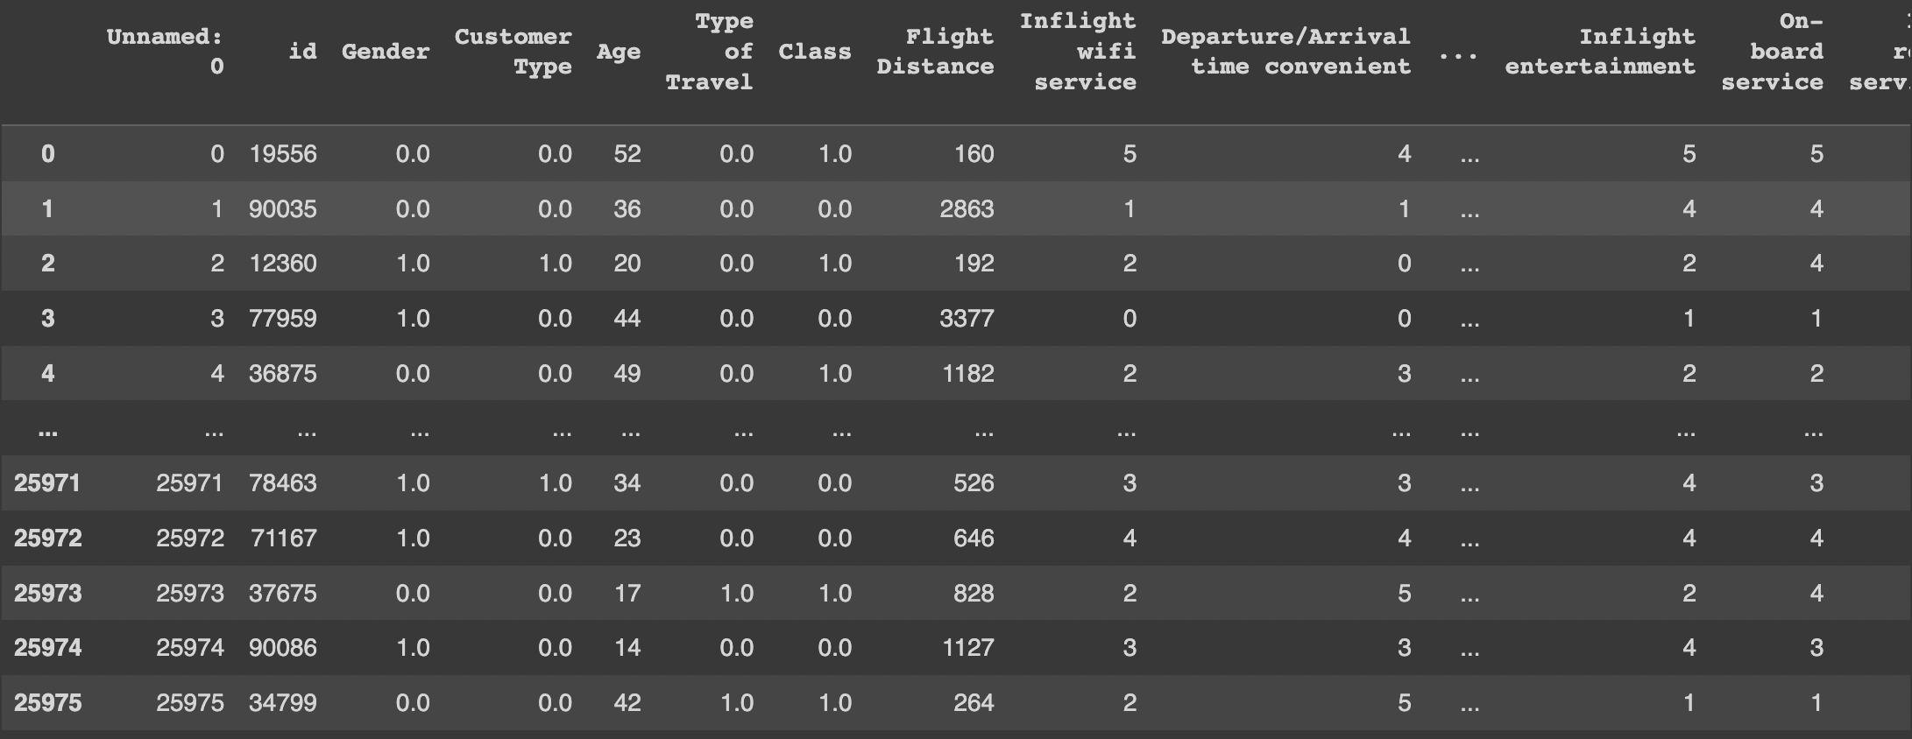

class_label =df['satisfaction']

df = df.drop(['satisfaction'], axis =1)

df = (df-df.min())/(df.max()-df.min())

df['satisfaction']=class_label

df

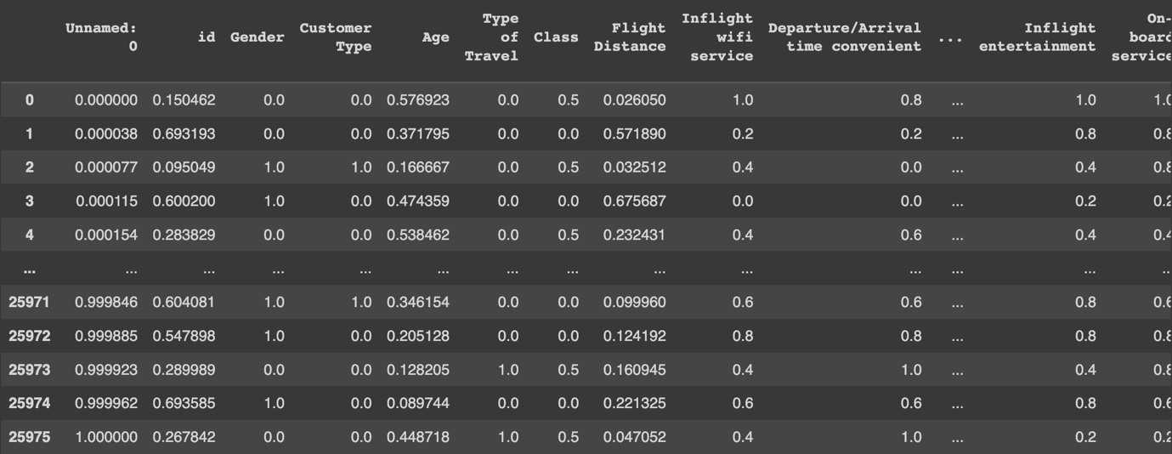

#pre-processing

mnist_test = df.copy()

l = preprocessing.LabelEncoder()

unnamed_0 = l.fit_transform(list(mnist_test["Unnamed: 0"]))

id = l.fit_transform(list(mnist_test["id"]))

gender = l.fit_transform(list(mnist_test["Gender"]))

customer_type = l.fit_transform(list(mnist_test["Customer Type"]))

age = l.fit_transform(list(mnist_test["Age"]))#AGE OF THE PASSENGER

type_of_travel = l.fit_transform(list(mnist_test["Type of Travel"]))

class_ = l.fit_transform(list(mnist_test["Class"]))

flight_distance = l.fit_transform(list(mnist_test["Flight Distance"]))

inflight_wifi_service = l.fit_transform(list(mnist_test["Inflight wifi service"]))

departure_arrival_time_convenient = l.fit_transform(list(mnist_test["Departure/Arrival time convenient"]))

ease_of_online_booking = l.fit_transform(list(mnist_test["Ease of Online booking"]))

gate_location = l.fit_transform(list(mnist_test["Gate location"]))

food_and_drink = l.fit_transform(list(mnist_test["Food and drink"]))

online_boarding = l.fit_transform(list(mnist_test["Online boarding"]))

seat_comfort = l.fit_transform(list(mnist_test["Seat comfort"]))

inflight_entertainment = l.fit_transform(list(mnist_test["Inflight entertainment"]))

onboard_service = l.fit_transform(list(mnist_test["On-board service"]))

leg_room_service = l.fit_transform(list(mnist_test["Leg room service"]))

baggage_handling = l.fit_transform(list(mnist_test["Baggage handling"]))

checkin_service = l.fit_transform(list(mnist_test["Checkin service"]))

inflight_service = l.fit_transform(list(mnist_test["Inflight service"]))

cleanliness = l.fit_transform(list(mnist_test["Cleanliness"]))

departure_delay = l.fit_transform(list(mnist_test["Departure Delay in Minutes"]))

arrival_delay = l.fit_transform(list(mnist_test["Arrival Delay in Minutes"]))

satisfaction = l.fit_transform(list(mnist_test["satisfaction"]))

### Model Preparation and Development

Steps used for machine learning model preparation are described below:

* + Convert the dataframe to training and validation/test subsets by taking a random sample of 80% of the data and defining it as train subset. This leaves 20% of the data for validation/testing
  + Create the validation/test set by dropping all of the rows that comprise the training set from the dataframe.
  + Create y_train by using using the last column of train (target class).
  + Create x_train by using all of the columns in train except the last one.
  + The validation set of y_val and x_val or (y_test and x_test), can be created using the same methodology that used to create y_train and x_train

import sklearn

# check column names in df

print(df.columns)

# modify the list of columns in x and y assignments accordingly

# modify the list of columns in x and y assignments accordingly

x = df[['Age', 'Gender', 'Class', 'Inflight wifi service', 'Departure/Arrival time convenient', 'Ease of Online booking', 'Gate location', 'Food and drink', 'Online boarding', 'Seat comfort', 'Inflight entertainment', 'On-board service', 'Leg room service', 'Baggage handling', 'Checkin service', 'Inflight service', 'Cleanliness', 'Departure Delay in Minutes', 'Arrival Delay in Minutes']]

y = df[['satisfaction']]

# Test options and evaluation metric

num_folds = 10

seed = 14

scoring = 'accuracy'

# Model Test/Train

# Splitting what we are trying to predict into 4 different arrays -

# X train is a section of the x array(attributes) and vise versa for Y(features)

# The test data will test the accuracy of the model created

x_train, x_test, y_train, y_test = sklearn.model_selection.train_test_split(x, y, test_size = 0.05, random_state=seed)

#splitting 5% of our data into test samples. If we train the model with higher data it already has seen that information and knows

#size of train and test subsets after splitting

np.shape(x_train), np.shape(x_test)

= Index(['Unnamed: 0', 'id', 'Gender', 'Customer Type', 'Age', 'Type of Travel',

'Class', 'Flight Distance', 'Inflight wifi service',

'Departure/Arrival time convenient', 'Ease of Online booking',

'Gate location', 'Food and drink', 'Online boarding', 'Seat comfort',

'Inflight entertainment', 'On-board service', 'Leg room service',

'Baggage handling', 'Checkin service', 'Inflight service',

'Cleanliness', 'Departure Delay in Minutes', 'Arrival Delay in Minutes',

'satisfaction'],

dtype='object')

((24677, 19), (1299, 19))

# Predictive analytics model development by comparing different Scikit-learn classification algorithms

from sklearn.preprocessing import StandardScaler

from sklearn.model_selection import train_test_split

from sklearn.model_selection import KFold

from sklearn.model_selection import cross_val_score

from sklearn.model_selection import GridSearchCV

from sklearn.metrics import classification_report

from sklearn.metrics import confusion_matrix, ConfusionMatrixDisplay

from sklearn.metrics import accuracy_score

from sklearn.pipeline import Pipeline

from sklearn.linear_model import LogisticRegression

from sklearn.tree import DecisionTreeClassifier

from sklearn.neighbors import KNeighborsClassifier

from sklearn.discriminant_analysis import LinearDiscriminantAnalysis

from sklearn.naive_bayes import GaussianNB

from sklearn.svm import SVC

from sklearn.ensemble import AdaBoostClassifier

from sklearn.ensemble import GradientBoostingClassifier

from sklearn.ensemble import RandomForestClassifier

from sklearn.ensemble import ExtraTreesClassifier

# create an imputer object

imputer = SimpleImputer(strategy='median')

# impute missing values in the x_train and x_test datasets

x_train = imputer.fit_transform(x_train)

x_test = imputer.transform(x_test)

models = []

models.append(('NB', GaussianNB()))

models.append(('SVM', SVC()))

models.append(('GBM', GradientBoostingClassifier()))

models.append(('RF', RandomForestClassifier()))

# evaluate each model in turn

results = []

names = []

print("Airline satisfaction")

for name, model in models:

  kfold = KFold(n_splits=num_folds,shuffle=True,random_state=seed)

  cv_results = cross_val_score(model, x_train, y_train, cv=kfold, scoring='accuracy')

  results.append(cv_results)

  names.append(name)

  msg = "%s: %f (%f)" % (name, cv_results.mean(), cv_results.std())

  msg += '\n'

  print(msg)

= Airline satisfaction

NB: 0.802326 (0.003559)

SVM: 0.927382 (0.005720)

GBM: 0.925356 (0.004690)

RF: 0.945780 (0.004119)

# Compare Algorithms' Performance

fig = plt.figure()

fig.suptitle('Algorithm Comparison')

ax = fig.add_subplot(111)

plt.boxplot(results)

ax.set_xticklabels(names)

plt.show()

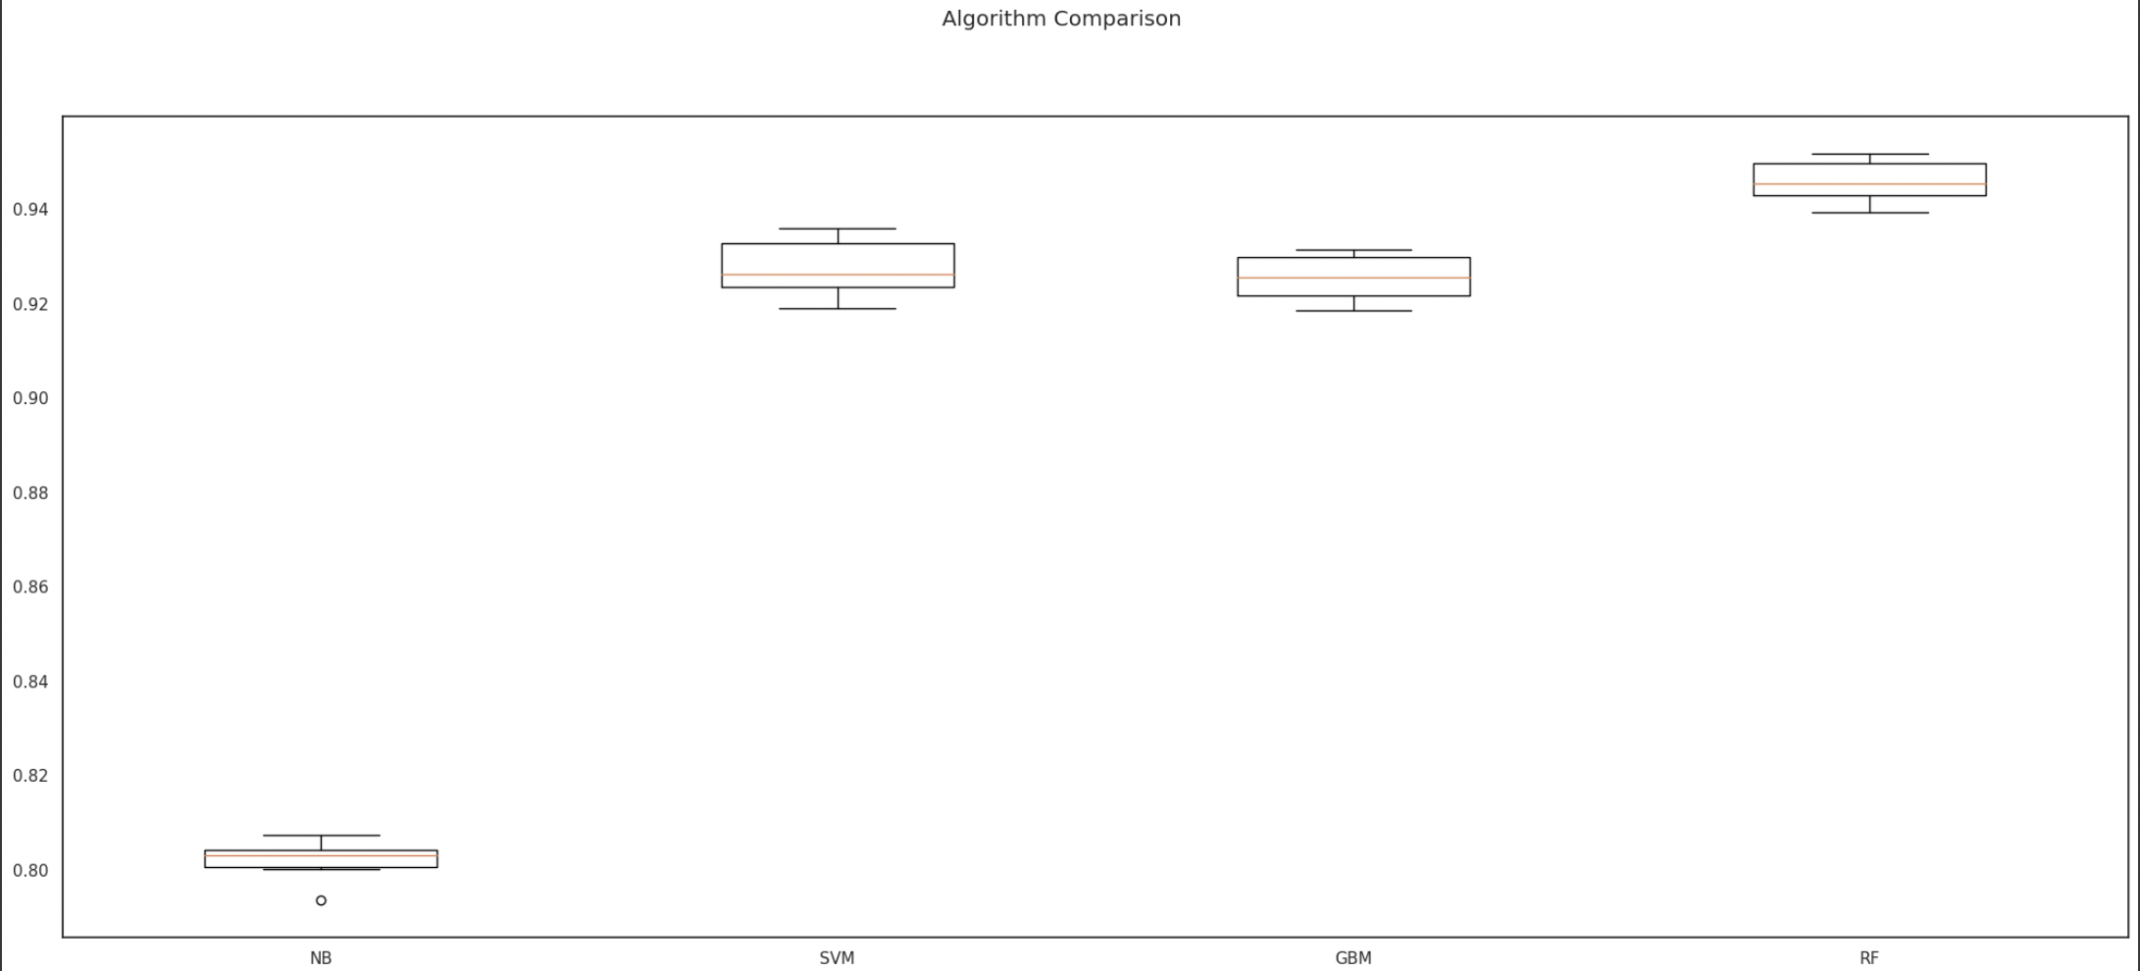

#Model Evaluation by testing with independent/external test data set.

# Make predictions on validation/test dataset

#Model Evaluation by testing with independent/external test data set.

# Make predictions on validation/test dataset

models.append(('DT', DecisionTreeClassifier()))

models.append(('NB', GaussianNB()))

models.append(('SVM', SVC()))

models.append(('GBM', GradientBoostingClassifier()))

models.append(('RF', RandomForestClassifier()))

dt = DecisionTreeClassifier()

nb = GaussianNB()

gb = GradientBoostingClassifier()

rf = RandomForestClassifier()

best_model = rf

best_model.fit(x_train, y_train)

y_pred = best_model.predict(x_test)

print("Best Model Accuracy Score on Test Set:", accuracy_score(y_test, y_pred))

Best model accuracy score on test set: 0.9337952270977675

#Model Performance Evaluation Metric 1 - Classification Report

print(classification_report(y_test, y_pred))

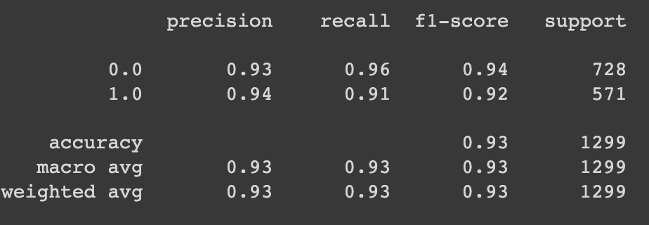

#Model Performance Evaluation Metric 2

#Confusion matrix

from sklearn.metrics import confusion_matrix, ConfusionMatrixDisplay

cm = confusion_matrix(y_test, y_pred)

disp = ConfusionMatrixDisplay(confusion_matrix=cm)

disp.plot()

plt.show()

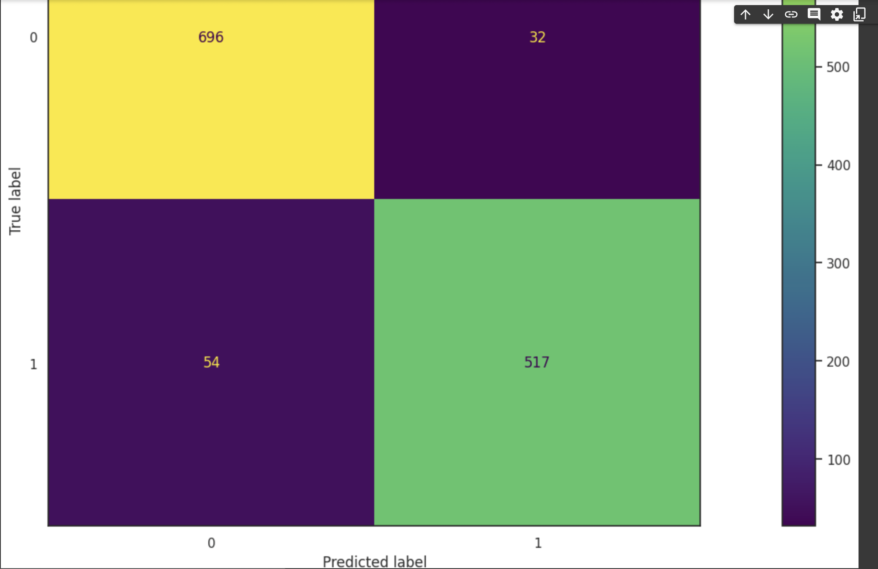

#Model Evaluation Metric 3- ROC-AUC curve

from sklearn.metrics import roc_auc_score

from sklearn.metrics import roc_curve

best_model = rf

best_model.fit(x_train, y_train)

rf_roc_auc = roc_auc_score(y_test,best_model.predict(x_test))

fpr,tpr,thresholds = roc_curve(y_test, best_model.predict_proba(x_test)[:,1])

plt.figure()

plt.plot(fpr,tpr,label = 'Random Forest(area = %0.2f)'% rf_roc_auc)

plt.plot([0,1],[0,1],'r--')

plt.xlim([0.0,1.0])

plt.ylim([0.0,1.05])

plt.xlabel('False positive rate')

plt.ylabel('True positive rate')

plt.title('Based on services offered’)

plt.legend(loc='lower right')

plt.savefig('LOC_ROC')

plt.show()

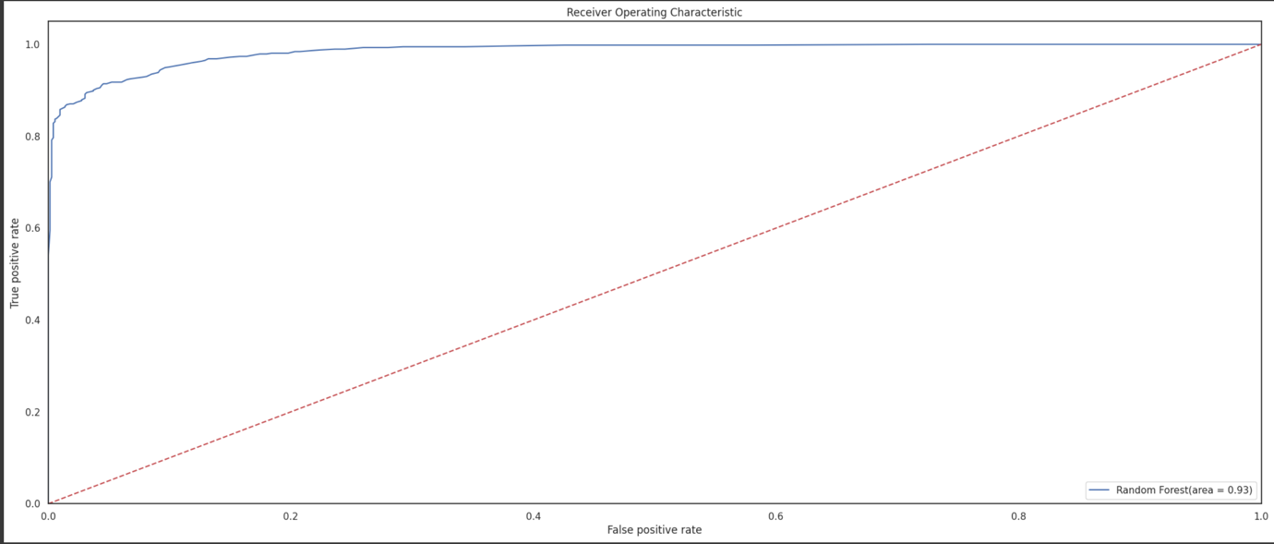

#Model Evaluation Metric 4-prediction report

for x in range(len(y_pred)):

  print("Predicted: ", y_pred[x], "Actual: ", y_test[x], "Data: ", x_test[x],)

Predicted: 0 Actual: 0 Data: (18, 1, 0, 9, 59, 0, 1, 57, 0, 0, 2, 1, 2)

Predicted: 1 Actual: 1 Data: (24, 0, 2, 14, 137, 0, 1, 69, 0, 0, 2, 0, 2)

Predicted: 0 Actual: 0 Data: (12, 1, 2, 34, 60, 0, 1, 44, 0, 33, 1, 0, 2)

Predicted: 1 Actual: 1 Data: (8, 0, 2, 14, 39, 0, 1, 70, 0, 0, 1, 0, 2)

Predicted: 1 Actual: 1 Data: (19, 0, 2, 20, 46, 0, 0, 15, 0, 0, 2, 0, 0)

Predicted: 1 Actual: 1 Data: (8, 1, 2, 22, 16, 0, 1, 47, 0, 0, 2, 0, 2)

Predicted: 0 Actual: 0 Data: (26, 0, 0, 34, 84, 0, 0, 54, 0, 25, 1, 2, 3)

Predicted: 0 Actual: 0 Data: (32, 1, 0, 9, 42, 0, 0, 30, 1, 1, 2, 1, 2)

Predicted: 0 Actual: 0 Data: (24, 1, 1, 14, 107, 0, 0, 57, 0, 17, 1, 0, 2)

Predicted: 0 Actual: 0 Data: (29, 1, 0, 28, 22, 0, 0, 41, 1, 35, 2, 2, 3)

Predicted: 0 Actual: 0 Data: (24, 1, 0, 32, 47, 0, 1, 7, 0, 19, 1, 1, 3)

Predicted: 0 Actual: 0 Data: (33, 1, 0, 14, 58, 0, 0, 27, 1, 25, 1, 2, 3)

Predicted: 0 Actual: 0 Data: (23, 1, 0, 41, 110, 1, 0, 22, 0, 10, 1, 3, 3)

Predicted: 1 Actual: 1 Data: (21, 0, 1, 25, 77, 0, 0, 58, 0, 14, 1, 0, 2)

Predicted: 0 Actual: 0 Data: (5, 1, 0, 13, 48, 0, 1, 37, 0, 12, 1, 0, 3)

Predicted: 0 Actual: 0 Data: (18, 1, 0, 9, 59, 0, 1, 57, 0, 0, 2, 1, 2)

Predicted: 0 Actual: 0 Data: (24, 1, 0, 1, 63, 0, 1, 53, 0, 1, 2, 1, 3)

Predicted: 0 Actual: 0 Data: (30, 1, 2, 28, 136, 0, 1, 55, 0, 0, 2, 0, 2)

Predicted: 0 Actual: 0 Data: (17, 1, 0, 28, 115, 0, 1, 20, 1, 36, 1, 3, 3)

Predicted: 1 Actual: 1 Data: (30, 0, 0, 22, 119, 0, 1, 20, 0, 19, 1, 2, 2)

Predicted: 0 Actual: 0 Data: (29, 1, 0, 22, 80, 0, 0, 44, 0, 14, 1, 1, 3)

Predicted: 1 Actual: 1 Data: (18, 0, 2, 26, 27, 0, 0, 66, 0, 1, 1, 0, 2)

Predicted: 1 Actual: 1 Data: (23, 1, 0, 28, 24, 0, 1, 45, 0, 4, 1, 0, 1)

Predicted: 0 Actual: 0 Data: (27, 0, 0, 31, 123, 0, 0, 43, 1, 10, 1, 0, 3)

Predicted: 1 Actual: 1 Data: (17, 1, 0, 28, 87, 0, 0, 81, 1, 0, 2, 0, 2)

Predicted: 0 Actual: 0 Data: (28, 0, 2, 22, 89, 0, 1, 4, 0, 12, 1, 1, 3)

Predicted: 1 Actual: 1 Data: (20, 1, 1, 7, 125, 0, 1, 53, 0, 0, 2, 0, 3)

Predicted: 0 Actual: 0 Data: (6, 1, 0, 35, 52, 0, 1, 77, 0, 0, 2, 0, 3)

Predicted: 0 Actual: 0 Data: (31, 1, 0, 8, 75, 0, 0, 55, 0, 6, 2, 2, 1)

Predicted: 1 Actual: 1 Data: (4, 1, 2, 27, 12, 0, 1, 70, 0, 0, 2, 4, 2)

Predicted: 0 Actual: 0 Data: (20, 1, 0, 8, 66, 0, 1, 24, 1, 26, 1, 1, 3)

Predicted: 1 Actual: 1 Data: (14, 1, 1, 22, 72, 0, 0, 76, 0, 2, 1, 0, 2)

Predicted: 0 Actual: 0 Data: (26, 1, 0, 22, 79, 0, 1, 41, 1, 14, 2, 1, 3)

Predicted: 0 Actual: 0 Data: (33, 1, 0, 18, 80, 1, 1, 60, 0, 2, 1, 2, 3)

Predicted: 1 Actual: 1 Data: (36, 1, 1, 38, 72, 0, 0, 40, 0, 0, 2, 0, 2)

Predicted: 0 Actual: 0 Data: (14, 1, 0, 17, 99, 0, 0, 63, 0, 5, 1, 0, 3)

Predicted: 1 Actual: 1 Data: (6, 1, 3, 28, 30, 0, 1, 74, 1, 14, 2, 0, 3)

Predicted: 1 Actual: 1 Data: (9, 1, 0, 11, 119, 0, 1, 77, 0, 12, 1, 0, 2)

Predicted: 0 Actual: 0 Data: (12, 1, 2, 34, 60, 0, 1, 44, 0, 33, 1, 0, 2)

Predicted: 1 Actual: 1 Data: (7, 1, 1, 25, 33, 0, 1, 30, 0, 0, 1, 0, 1)

Predicted: 1 Actual: 1 Data: (9, 0, 2, 15, 43, 0, 1, 62, 0, 2, 1, 0, 2)

Predicted: 1 Actual: 1 Data: (24, 1, 2, 5, 67, 0, 0, 51, 1, 6, 1, 0, 3)

Predicted: 0 Actual: 0 Data: (11, 1, 0, 29, 125, 0, 0, 44, 1, 0, 1, 3, 3)

Predicted: 1 Actual: 1 Data: (18, 1, 3, 13, 21, 0, 0, 84, 0, 0, 1, 0, 1)

Predicted: 1 Actual: 1 Data: (39, 0, 2, 28, 28, 0, 2, 16, 0, 11, 1, 0, 2)

Predicted: 1 Actual: 1 Data: (17, 1, 2, 8, 12, 0, 1, 21, 0, 6, 2, 0, 2)

Predicted: 0 Actual: 0 Data: (26, 1, 0, 22, 36, 0, 0, 30, 1, 23, 1, 2, 3)

Predicted: 1 Actual: 1 Data: (31, 1, 0, 14, 14, 0, 1, 37, 0, 4, 2, 0, 3)

Predicted: 1 Actual: 1 Data: (25, 1, 0, 27, 97, 0, 0, 78, 0, 0, 2, 0, 2)

Predicted: 1 Actual: 1 Data: (0, 1, 1, 22, 34, 0, 0, 87, 0, 0, 2, 0, 2)

Predicted: 1 Actual: 1 Data: (18, 1, 3, 35, 115, 1, 1, 74, 0, 12, 1, 0, 3)

Predicted: 0 Actual: 0 Data: (26, 1, 0, 28, 112, 0, 0, 67, 0, 12, 1, 2, 3)

Predicted: 1 Actual: 1 Data: (0, 1, 1, 22, 34, 0, 0, 87, 0, 0, 2, 0, 2)

Predicted: 1 Actual: 1 Data: (8, 1, 1, 14, 114, 0, 1, 59, 0, 0, 2, 0, 2)

Predicted: 0 Actual: 0 Data: (24, 1, 0, 34, 96, 0, 0, 11, 1, 8, 2, 0, 3)

Predicted: 1 Actual: 1 Data: (22, 1, 1, 14, 67, 0, 1, 66, 0, 0, 0, 0, 2)

Predicted: 1 Actual: 1 Data: (19, 0, 0, 22, 90, 0, 0, 40, 0, 4, 1, 0, 2)

Predicted: 1 Actual: 1 Data: (34, 0, 2, 14, 41, 0, 0, 15, 0, 15, 1, 0, 2)

Predicted: 0 Actual: 0 Data: (12, 1, 0, 28, 126, 0, 1, 18, 1, 17, 1, 2, 3)

Predicted: 1 Actual: 1 Data: (29, 0, 2, 25, 78, 0, 0, 69, 0, 0, 2, 0, 2)

Predicted: 1 Actual: 1 Data: (11, 0, 1, 9, 5, 0, 1, 35, 0, 0, 1, 0, 2)

Predicted: 1 Actual: 1 Data: (20, 1, 2, 14, 84, 0, 0, 44, 0, 4, 1, 0, 3)

Predicted: 1 Actual: 1 Data: (7, 1, 1, 14, 4, 0, 1, 78, 0, 0, 2, 0, 2)

Predicted: 0 Actual: 0 Data: (29, 1, 0, 22, 135, 1, 0, 30, 1, 17, 2, 3, 3)

Predicted: 1 Actual: 1 Data: (17, 0, 2, 22, 82, 0, 0, 46, 0, 5, 2, 0, 2)

Predicted: 0 Actual: 0 Data: (33, 1, 0, 39, 108, 0, 0, 9, 1, 15, 1, 3, 2)

Predicted: 0 Actual: 0 Data: (23, 1, 0, 22, 1, 0, 1, 15, 1, 12, 1, 1, 3)

Predicted: 0 Actual: 0 Data: (21, 1, 0, 23, 140, 0, 1, 30, 1, 12, 1, 1, 3)

Predicted: 1 Actual: 1 Data: (30, 0, 0, 22, 119, 0, 1, 20, 0, 19, 1, 2, 2)

Predicted: 0 Actual: 0 Data: (25, 1, 3, 24, 34, 0, 1, 59, 0, 8, 2, 2, 2)

Predicted: 0 Actual: 0 Data: (25, 1, 2, 19, 47, 1, 1, 32, 0, 21, 1, 1, 1)

Predicted: 1 Actual: 1 Data: (5, 1, 2, 28, 131, 0, 0, 78, 0, 0, 2, 0, 2)

Predicted: 1 Actual: 1 Data: (7, 0, 1, 19, 122, 0, 1, 60, 0, 0, 2, 0, 2)

Predicted: 0 Actual: 0 Data: (26, 1, 0, 22, 79, 0, 1, 41, 1, 14, 2, 1, 3)

Predicted: 0 Actual: 0 Data: (6, 1, 0, 8, 7, 0, 0, 14, 1, 19, 1, 0, 3)

Predicted: 1 Actual: 1 Data: (10, 1, 2, 22, 62, 0, 1, 75, 1, 4, 2, 0, 2)

Predicted: 0 Actual: 0 Data: (14, 1, 0, 22, 82, 1, 0, 47, 1, 0, 2, 2, 3)

Predicted: 1 Actual: 1 Data: (32, 0, 2, 32, 103, 0, 0, 49, 0, 0, 1, 1, 2)

Predicted: 1 Actual: 1 Data: (10, 1, 1, 22, 48, 0, 0, 83, 0, 0, 2, 0, 2)

Predicted: 1 Actual: 1 Data: (10, 1, 1, 14, 89, 0, 1, 70, 0, 0, 2, 0, 3)

Predicted: 1 Actual: 1 Data: (22, 1, 1, 22, 50, 0, 0, 60, 0, 0, 2, 0, 3)

Predicted: 0 Actual: 0 Data: (22, 1, 0, 22, 106, 1, 0, 6, 1, 16, 0, 0, 3)

Predicted: 0 Actual: 0 Data: (23, 1, 1, 17, 87, 0, 1, 38, 0, 3, 2, 0, 3)

Predicted: 1 Actual: 1 Data: (32, 0, 2, 32, 103, 0, 0, 49, 0, 0, 1, 1, 2)

Predicted: 1 Actual: 1 Data: (32, 0, 3, 34, 55, 0, 1, 14, 0, 25, 0, 0, 2)

Predicted: 1 Actual: 1 Data: (9, 1, 2, 22, 128, 0, 1, 59, 0, 18, 2, 1, 2)

Predicted: 1 Actual: 1 Data: (24, 1, 1, 18, 49, 0, 1, 41, 0, 4, 1, 4, 3)

Predicted: 0 Actual: 0 Data: (31, 1, 3, 27, 105, 1, 0, 71, 0, 14, 1, 1, 2)

Predicted: 1 Actual: 1 Data: (11, 0, 0, 27, 65, 0, 0, 49, 1, 2, 1, 0, 2)

Predicted: 0 Actual: 0 Data: (31, 0, 0, 34, 54, 0, 0, 14, 0, 10, 1, 3, 3)

Predicted: 0 Actual: 0 Data: (8, 1, 0, 26, 128, 0, 1, 23, 1, 17, 1, 0, 1)

Predicted: 1 Actual: 1 Data: (17, 1, 0, 28, 87, 0, 0, 81, 1, 0, 2, 0, 2)

Predicted: 1 Actual: 1 Data: (20, 0, 2, 39, 32, 0, 1, 60, 0, 0, 2, 1, 2)

Predicted: 0 Actual: 0 Data: (36, 1, 0, 22, 132, 0, 0, 10, 0, 23, 1, 3, 2)

Predicted: 0 Actual: 0 Data: (20, 1, 0, 8, 36, 0, 0, 9, 1, 0, 1, 1, 2)

Predicted: 0 Actual: 0 Data: (13, 1, 0, 8, 100, 0, 0, 17, 1, 10, 1, 1, 2)

Predicted: 1 Actual: 1 Data: (20, 0, 2, 7, 93, 0, 0, 64, 0, 0, 2, 0, 2)

Predicted: 0 Actual: 0 Data: (24, 1, 2, 9, 59, 0, 0, 62, 0, 24, 1, 1, 3)

Predicted: 0 Actual: 0 Data: (23, 0, 0, 28, 68, 0, 1, 21, 1, 2, 1, 0, 3)

Predicted: 0 Actual: 0 Data: (20, 1, 0, 8, 66, 0, 1, 24, 1, 26, 1, 1, 3)

Predicted: 1 Actual: 1 Data: (8, 1, 2, 22, 16, 0, 1, 47, 0, 0, 2, 0, 2)

Predicted: 1 Actual: 1 Data: (8, 0, 2, 14, 39, 0, 1, 70, 0, 0, 1, 0, 2)

Predicted: 1 Actual: 1 Data: (20, 0, 2, 39, 32, 0, 1, 60, 0, 0, 2, 1, 2)

Predicted: 1 Actual: 1 Data: (25, 1, 0, 27, 97, 0, 0, 78, 0, 0, 2, 0, 2)

Predicted: 1 Actual: 1 Data: (24, 0, 0, 1, 75, 0, 0, 20, 0, 10, 1, 0, 2)

Predicted: 1 Actual: 1 Data: (19, 1, 0, 29, 55, 0, 0, 11, 1, 0, 2, 0, 3)

Predicted: 0 Actual: 0 Data: (20, 1, 0, 15, 108, 0, 0, 16, 1, 30, 1, 2, 2)

Predicted: 1 Actual: 1 Data: (35, 0, 3, 28, 66, 0, 1, 48, 0, 17, 2, 2, 2)

Predicted: 0 Actual: 0 Data: (16, 1, 2, 28, 62, 0, 1, 60, 0, 6, 1, 1, 3)

Predicted: 1 Actual: 1 Data: (32, 0, 2, 32, 103, 0, 0, 49, 0, 0, 1, 1, 2)

Predicted: 1 Actual: 1 Data: (17, 1, 2, 8, 12, 0, 1, 21, 0, 6, 2, 0, 2)

Predicted: 0 Actual: 0 Data: (26, 1, 0, 12, 59, 1, 1, 57, 1, 14, 2, 2, 3)

Predicted: 0 Actual: 0 Data: (17, 1, 0, 28, 116, 0, 1, 70, 1, 16, 2, 0, 3)

Predicted: 1 Actual: 1 Data: (13, 1, 2, 22, 79, 0, 1, 75, 0, 0, 2, 0, 2)

Predicted: 1 Actual: 1 Data: (12, 0, 2, 29, 14, 0, 0, 57, 1, 14, 0, 0, 2)

Predicted: 1 Actual: 1 Data: (27, 1, 2, 34, 70, 1, 1, 34, 1, 10, 1, 0, 2)

Predicted: 0 Actual: 0 Data: (27, 1, 0, 27, 6, 0, 0, 23, 1, 33, 1, 1, 2)

Predicted: 0 Actual: 0 Data: (28, 1, 0, 14, 93, 0, 1, 5, 1, 17, 1, 2, 3)

Predicted: 1 Actual: 1 Data: (22, 0, 1, 28, 113, 0, 0, 50, 0, 13, 1, 0, 2)

Predicted: 0 Actual: 0 Data: (25, 1, 3, 42, 109, 0, 0, 56, 0, 2, 1, 0, 3)

Predicted: 0 Actual: 0 Data: (18, 1, 0, 20, 81, 0, 1, 58, 1, 0, 2, 1, 3)

Predicted: 1 Actual: 1 Data: (7, 0, 2, 9, 94, 0, 0, 69, 1, 0, 2, 0, 2)

Predicted: 1 Actual: 1 Data: (32, 1, 0, 14, 118, 0, 0, 48, 0, 4, 1, 0, 2)

Predicted: 0 Actual: 0 Data: (20, 1, 0, 8, 36, 0, 0, 9, 1, 0, 1, 1, 2)

Predicted: 0 Actual: 0 Data: (24, 1, 0, 10, 129, 0, 2, 37, 0, 37, 0, 3, 1)

Predicted: 1 Actual: 1 Data: (12, 0, 0, 27, 70, 0, 0, 49, 1, 0, 1, 0, 2)

Predicted: 0 Actual: 0 Data: (15, 1, 2, 14, 23, 0, 1, 36, 0, 19, 1, 3, 3)

Predicted: 1 Actual: 1 Data: (15, 1, 1, 22, 92, 0, 1, 68, 0, 6, 2, 0, 2)

Predicted: 0 Actual: 0 Data: (6, 1, 0, 35, 52, 0, 1, 77, 0, 0, 2, 0, 3)

Predicted: 0 Actual: 0 Data: (12, 1, 0, 28, 126, 0, 1, 18, 1, 17, 1, 2, 3)

Predicted: 1 Actual: 1 Data: (33, 0, 0, 6, 52, 0, 1, 39, 0, 3, 2, 2, 2)

Predicted: 0 Actual: 0 Data: (27, 0, 0, 31, 123, 0, 0, 43, 1, 10, 1, 0, 3)

Predicted: 0 Actual: 0 Data: (20, 1, 0, 14, 23, 0, 1, 13, 0, 14, 1, 1, 3)

Predicted: 0 Actual: 0 Data: (10, 1, 0, 8, 28, 0, 0, 73, 0, 0, 2, 1, 2)

Predicted: 0 Actual: 0 Data: (23, 1, 2, 20, 58, 0, 0, 47, 0, 4, 1, 1, 3)

Predicted: 1 Actual: 1 Data: (30, 0, 2, 28, 127, 0, 1, 31, 0, 2, 2, 0, 3)

Predicted: 1 Actual: 1 Data: (24, 0, 0, 1, 75, 0, 0, 20, 0, 10, 1, 0, 2)

Predicted: 1 Actual: 1 Data: (15, 0, 0, 22, 95, 0, 1, 60, 0, 0, 2, 0, 2)

Predicted: 0 Actual: 0 Data: (36, 1, 0, 22, 132, 0, 0, 10, 0, 23, 1, 3, 2)

Predicted: 1 Actual: 1 Data: (7, 1, 1, 25, 33, 0, 1, 30, 0, 0, 1, 0, 1)

Predicted: 1 Actual: 1 Data: (11, 0, 1, 22, 63, 0, 0, 72, 0, 6, 1, 0, 2)

Predicted: 1 Actual: 1 Data: (22, 0, 1, 28, 113, 0, 0, 50, 0, 13, 1, 0, 2)

Predicted: 0 Actual: 0 Data: (24, 0, 0, 42, 54, 1, 0, 43, 1, 26, 1, 2, 1)

Predicted: 0 Actual: 0 Data: (20, 1, 0, 17, 92, 0, 0, 10, 1, 21, 1, 1, 3)

Predicted: 0 Actual: 0 Data: (24, 1, 0, 20, 46, 0, 0, 29, 1, 21, 1, 3, 3)

Predicted: 1 Actual: 1 Data: (37, 0, 2, 8, 91, 1, 0, 28, 0, 0, 2, 1, 2)

Predicted: 0 Actual: 0 Data: (24, 0, 1, 26, 130, 1, 0, 49, 0, 0, 2, 2, 2)

Predicted: 0 Actual: 0 Data: (35, 1, 2, 28, 80, 0, 0, 43, 0, 19, 1, 3, 3)

Predicted: 0 Actual: 0 Data: (19, 1, 0, 16, 105, 0, 1, 2, 1, 19, 1, 2, 3)

Predicted: 0 Actual: 0 Data: (36, 1, 0, 22, 132, 0, 0, 10, 0, 23, 1, 3, 2)

Predicted: 0 Actual: 0 Data: (24, 1, 0, 32, 47, 0, 1, 7, 0, 19, 1, 1, 3)

Predicted: 1 Actual: 1 Data: (24, 0, 2, 14, 137, 0, 1, 69, 0, 0, 2, 0, 2)

Predicted: 1 Actual: 1 Data: (20, 1, 0, 28, 66, 0, 1, 57, 0, 12, 2, 0, 2)

Predicted: 1 Actual: 1 Data: (32, 1, 0, 14, 118, 0, 0, 48, 0, 4, 1, 0, 2)

Predicted: 0 Actual: 0 Data: (27, 1, 3, 24, 63, 0, 1, 42, 0, 25, 1, 2, 2)

Predicted: 1 Actual: 1 Data: (8, 1, 0, 28, 55, 0, 1, 74, 0, 0, 2, 0, 2)

Predicted: 1 Actual: 1 Data: (10, 1, 1, 14, 49, 0, 1, 67, 0, 0, 2, 0, 2)

Predicted: 0 Actual: 0 Data: (25, 1, 0, 8, 66, 0, 0, 39, 1, 12, 1, 1, 3)

Predicted: 0 Actual: 0 Data: (15, 1, 2, 14, 23, 0, 1, 36, 0, 19, 1, 3, 3)

Predicted: 1 Actual: 1 Data: (24, 0, 3, 34, 106, 1, 0, 59, 0, 10, 2, 0, 2)

Predicted: 1 Actual: 1 Data: (18, 1, 1, 24, 32, 0, 1, 55, 0, 8, 2, 1, 2)

Predicted: 0 Actual: 0 Data: (28, 0, 0, 34, 71, 0, 1, 51, 1, 14, 1, 0, 2)

Predicted: 1 Actual: 1 Data: (22, 1, 1, 22, 50, 0, 0, 60, 0, 0, 2, 0, 3)

Predicted: 0 Actual: 0 Data: (13, 1, 2, 7, 70, 0, 1, 49, 0, 0, 2, 0, 2)

Predicted: 1 Actual: 1 Data: (17, 0, 2, 22, 82, 0, 0, 46, 0, 5, 2, 0, 2)

Predicted: 1 Actual: 1 Data: (18, 0, 2, 26, 27, 0, 0, 66, 0, 1, 1, 0, 2)

Predicted: 1 Actual: 1 Data: (32, 1, 0, 39, 57, 0, 0, 35, 0, 22, 2, 0, 1)

Predicted: 1 Actual: 1 Data: (5, 0, 2, 27, 49, 0, 1, 49, 0, 0, 1, 0, 2)

Predicted: 1 Actual: 1 Data: (26, 0, 2, 14, 15, 1, 1, 3, 0, 0, 2, 0, 2)

Predicted: 1 Actual: 1 Data: (9, 1, 0, 34, 74, 0, 1, 68, 0, 15, 2, 0, 2)

Predicted: 1 Actual: 1 Data: (2, 1, 1, 15, 24, 0, 1, 71, 0, 0, 2, 0, 2)

Predicted: 0 Actual: 0 Data: (2, 1, 0, 19, 105, 0, 0, 53, 1, 0, 2, 0, 3)

Predicted: 1 Actual: 1 Data: (13, 1, 2, 27, 83, 0, 0, 53, 0, 0, 2, 0, 2)

Predicted: 1 Actual: 1 Data: (24, 0, 2, 14, 137, 0, 1, 69, 0, 0, 2, 0, 2)

Predicted: 1 Actual: 1 Data: (16, 0, 0, 8, 80, 0, 0, 56, 0, 0, 2, 0, 2)

Predicted: 0 Actual: 0 Data: (16, 1, 0, 34, 70, 0, 0, 26, 0, 25, 1, 0, 3)

Predicted: 1 Actual: 1 Data: (20, 1, 1, 7, 125, 0, 1, 53, 0, 0, 2, 0, 3)

Predicted: 1 Actual: 1 Data: (20, 0, 2, 8, 44, 0, 1, 55, 0, 16, 1, 0, 2)

Predicted: 0 Actual: 0 Data: (29, 0, 0, 7, 95, 0, 1, 66, 1, 17, 1, 2, 2)

Predicted: 1 Actual: 1 Data: (20, 1, 2, 34, 61, 0, 0, 62, 0, 16, 2, 0, 3)

Predicted: 0 Actual: 0 Data: (25, 1, 3, 42, 109, 0, 0, 56, 0, 2, 1, 0, 3)

Predicted: 1 Actual: 1 Data: (10, 1, 1, 14, 49, 0, 1, 67, 0, 0, 2, 0, 2)

Predicted: 1 Actual: 1 Data: (9, 1, 2, 22, 128, 0, 1, 59, 0, 18, 2, 1, 2)

Predicted: 1 Actual: 1 Data: (7, 0, 1, 22, 34, 0, 0, 69, 0, 14, 2, 0, 2)

Predicted: 0 Actual: 0 Data: (25, 1, 3, 42, 109, 0, 0, 56, 0, 2, 1, 0, 3)

Predicted: 1 Actual: 1 Data: (25, 1, 0, 25, 63, 0, 1, 58, 0, 5, 1, 0, 3)

Predicted: 0 Actual: 0 Data: (24, 1, 2, 9, 59, 0, 0, 62, 0, 24, 1, 1, 3)

Predicted: 1 Actual: 1 Data: (24, 1, 2, 5, 67, 0, 0, 51, 1, 6, 1, 0, 3)

Predicted: 0 Actual: 0 Data: (18, 1, 0, 9, 59, 0, 1, 57, 0, 0, 2, 1, 2)

Predicted: 0 Actual: 0 Data: (23, 1, 1, 36, 61, 0, 0, 61, 0, 0, 2, 1, 2)

Predicted: 1 Actual: 1 Data: (21, 0, 1, 25, 77, 0, 0, 58, 0, 14, 1, 0, 2)

Predicted: 1 Actual: 1 Data: (36, 1, 1, 38, 72, 0, 0, 40, 0, 0, 2, 0, 2)

Predicted: 0 Actual: 0 Data: (13, 1, 0, 8, 100, 0, 0, 17, 1, 10, 1, 1, 2)

Predicted: 1 Actual: 1 Data: (22, 1, 1, 22, 50, 0, 0, 60, 0, 0, 2, 0, 3)

## Stage 2: Algorithm Implementation Stage

1. Implementation of best performing algorithm as a desktop Tkinter software tool.
2. Deployment of the tool as a web or cloud enabled platform tool.

Once the best performing algorithm and machine learning model for heart disease prediction has been identified from stage 1, the implementation of the algorithm as a desktop software tool using python Tkinter package.

The Pycharm project for the implementation is available at this google drive link:

<https://drive.google.com/drive/folders/1b2LyirWXzKWBCBn6m0eyTz_VNjI_Bwy4?usp=share_link>

## Stage 3: Software Deployment Stage

Although the airline passenger satisfaction prediction software was initially used as a desktop tool, it soon became clear that a more user-friendly and accessible platform was required. The desktop product could only be utilised by a small number of airline sector stakeholders due to deployment restrictions, which reduced its potential effect. With Flask API, a robust and scalable micro web framework written in Python, the software was made available as a web-based tool to address this. A larger spectrum of airline industry stakeholders, including care teams, travel brokers, and passengers themselves, may readily utilise this web-based platform. In order to maximise customer happiness and enhance industry strategic decision-making, it gives real-time access to the prediction model. The platform is also adaptable and expandable, making it simple to update and enhance over time. Overall, this project serves as an example of how crucial it is to deploy data-driven software in a way that maximises its usefulness and accessibility for all parties involved. <https://drive.google.com/drive/folders/1b2LyirWXzKWBCBn6m0eyTz_VNjI_Bwy4?usp=share_link>

# Conclusions

## This paper describes the ST1 capstone project, which required creating a Python-based data-driven software platform for predicting airline passenger happiness. The platform was created to make predictions about the likelihood of passenger happiness on flights using past data and insights from multiple sources. The initiative may be applied to more stakeholders in the aviation sector since the predictive analytics tools were made accessible as both desktop software products and web-based capabilities. A wide range of users, including care teams, travel agencies, and passengers themselves, may quickly use the prediction model thanks to the web-based deployment technique that made use of the Flask API. The platform has shown to be an excellent tool for improving customer happiness and guiding strategic decision-making in the airline sector by giving real-time access to the prediction model. This project can serve as a model for future data-driven software development initiatives in the airline sector since it emphasises the value of delivering data-driven software in a way that maximises its usability and accessibility for all parties concerned.

## References

1. “University of Canberra Single Sign On - Error !,” *idp.canberra.edu.au*. https://uclearn.canberra.edu.au/courses/13571/assignments/105232 (accessed Apr. 30, 2023).
2. “Airline Passenger Satisfaction,” *www.kaggle.com*. https://www.kaggle.com/datasets/mysarahmadbhat/airline-passenger-satisfaction/code (accessed Apr. 30, 2023).
3. “Customer Experience,” *Qantas News Room*, 2015. https://www.qantasnewsroom.com.au/topic/customer-experience/
4. my Git-Hub : <https://github.com/ugyal/MY-ST_Capstone_Project_Report>